**JavaScript Challenges**

In this assignment you will complete five distinct challenges that demonstrate your ability to write JavaScript (and some CSS) code. Download the code and you will find five html pages: challenge1.html, challenge2.html, challenge3.html, challenge4.html, and challenge5.html. The first four challenges are based on material found at: <https://en.wikiversity.org/wiki/Web_Design/JavaScript_Challenges>

Upload your files to a server and submit the URL.

**Challenge 1:**

The aim of this challenge is to only display the email paragraph when the checkbox is checked, but we'll break that down into smaller tasks!

**Step 1: Hiding the email fields by default**

Add some plain old CSS style so that the "emailpara" paragraph isn't displayed when the page first loads (using the CSS 'display' property). Test to make sure this works.

**Step 2: Adding a function template**

Create a new function called toggleEmail(). Add an event so that when the checkbox is clicked your function is called and *test that it works*! In the function, change the display property of the email field.

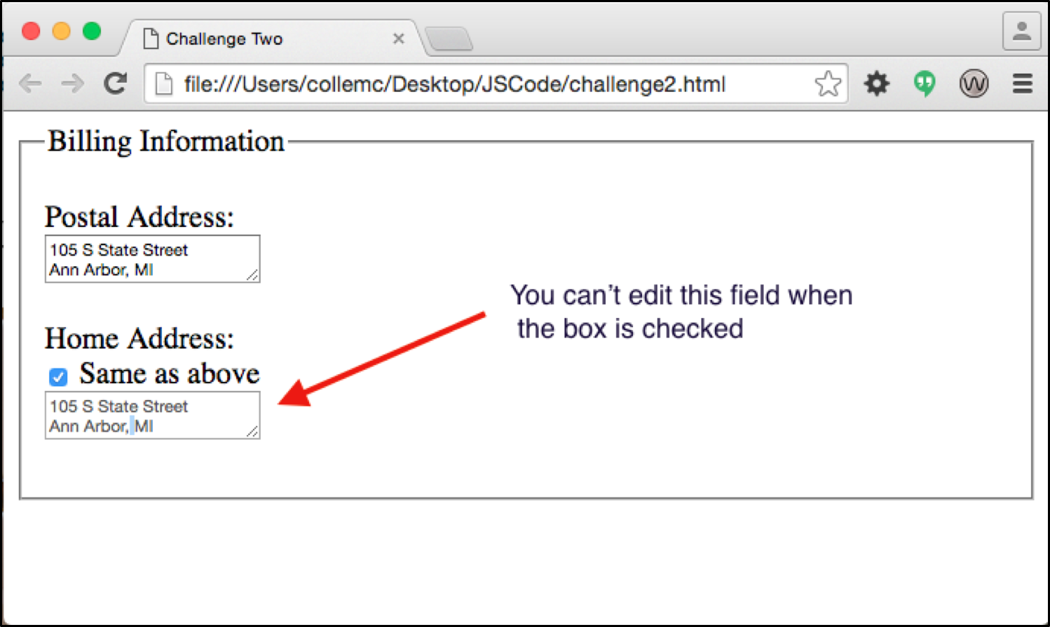

**Step 3: Making the email field toggle**

When you test your form at the moment, you'll notice that you can click on the checkbox and the email field displays, but when you un-check the checkbox the extra paragraph doesn't hide itself again! Add an if-else statement to our toggleEmail() function that checks to see if the checkbox is currently checked. If it is, we want to display our "emailpara" paragraph, otherwise we want to hide it.

To do this, we need to know how we can find out if a checkbox is currently checked... luckily for us, W3Schools's [HTML DOM Checkbox](http://www.w3schools.com/jsref/dom_obj_checkbox.asp) reference tells us that a checkbox element has a property called 'checked' that is either true or false.

**Challenge 2:**

The aim of this challenge is to automatically copy the postal address to the home address field if a user checks the "Same as above" checkbox. In addition to this, we'll disable the home address field when the checkbox is checked. (When a field is disabled, it can not be edited.) When the checkbox is unchecked the field should become enabled again, and be reset to blank.

**Challenge 3:**

Check out this page:

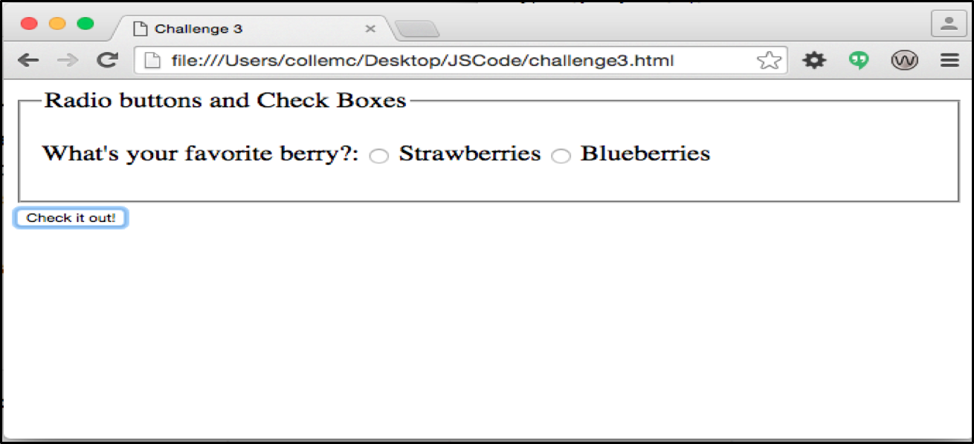

In this page you will only trigger the action field (to go to Challenge 4) if at least one of the fields is checked. If nothing is checked, nothing should happen on submit. ***In addition, only one radio button should be active at any given time.***

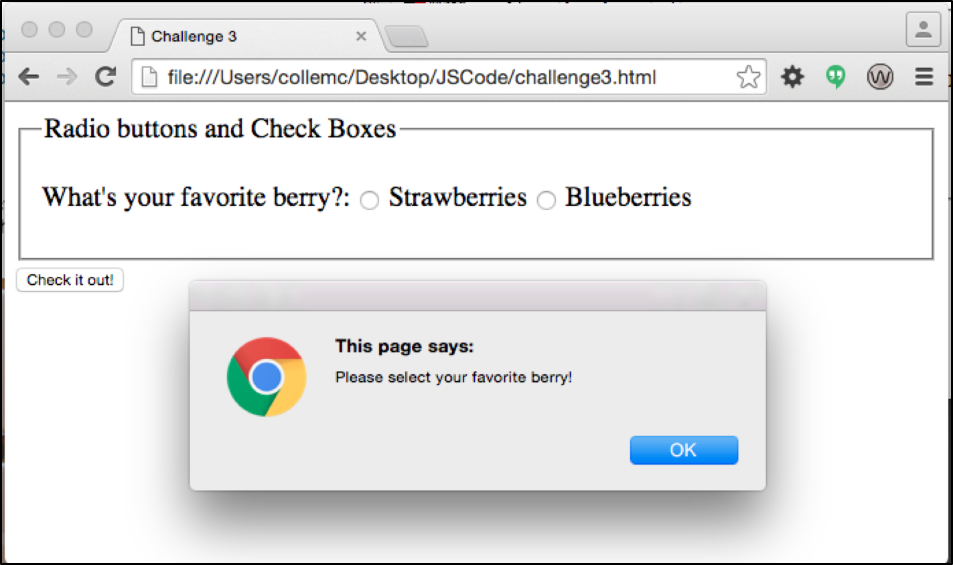

A tricky part to this challenge is making sure to NOT send the email if no field is selected. JavaScript's return statement lets you immediately drop out of a program if there's no reason to continue. In our case, when we find that the user hasn't selected an option we want to cancel submitting the incomplete form. return false will tell JavaScript to cancel submitting, but there's one little chunk of code missing. Take a read through [JavaScript Kit's Accessing and Validating Forms](http://www.javascriptkit.com/javatutors/form6.shtml) page to find what you're missing to complete this puzzle.

**Challenge 4:**

This challenge will help you create in-line error messages that only appear when they need to! Paste the following form into a page:

**Step 1: Some plain old styling**

First, just some plain old CSS! Add some style so that the error messages use red text, and make them dramatic! Note how the error messages have been given a class="errormsg".

Once they look the way you want them, use CSS to hide them by default.

**Step 2: Setting up your checkForm() function**

This step will be similar to the Peekaboo challenge above (Challenge 1). When the form is submitted, our checkForm() function is called. If the "fullname" field is empty, then we want to display the "nameerrormsg" paragraph.

After you've got that working, add a similar check for the street address.

Make sure you're showing the message if there's an error, but you'll also need to hide the error message if everything's ok!

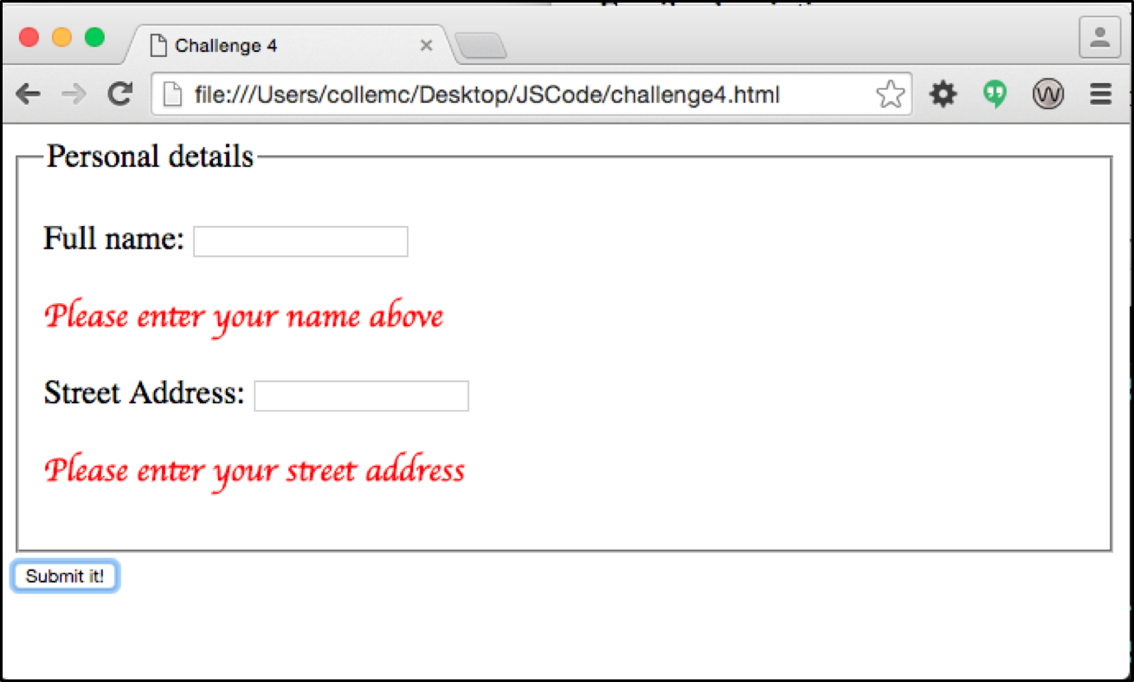

Make sure to check all the possible scenarios!! Submission shouldn’t happen unless all the data is filled in. And error messages shouldn’t appear unless data is missing.

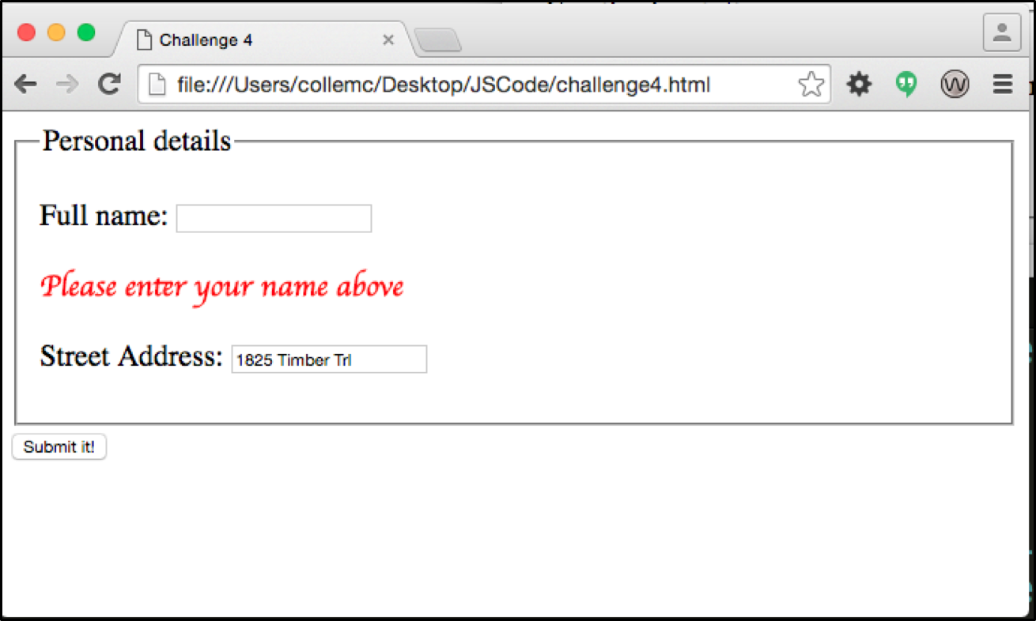

**Challenge 5:**

In this challenge you will be given the HTML. You are responsible for changing the background-image and content of elements in the page. The div with the id of “image” has a blue background and the text states “Hover over an image below”. This is the look it should have whenever the mouse is not over one of the three thumbnail images and none of the images are in focus.

Link to file: (<https://drive.google.com/a/umich.edu/file/d/0B8kbelne3pTVS3otcERVZmk5UkU/view?usp=sharing>)

See the default look below:

|  |  |
| --- | --- |
|  |  |
|  |  |

When the mouse is over a thumbnail image or an image is in focus, the text in the div should change to ***img alt text*** and the background should change to the ***img src***. When the mouse moves away from the image or the focus is removed, the div should go back to the default look.

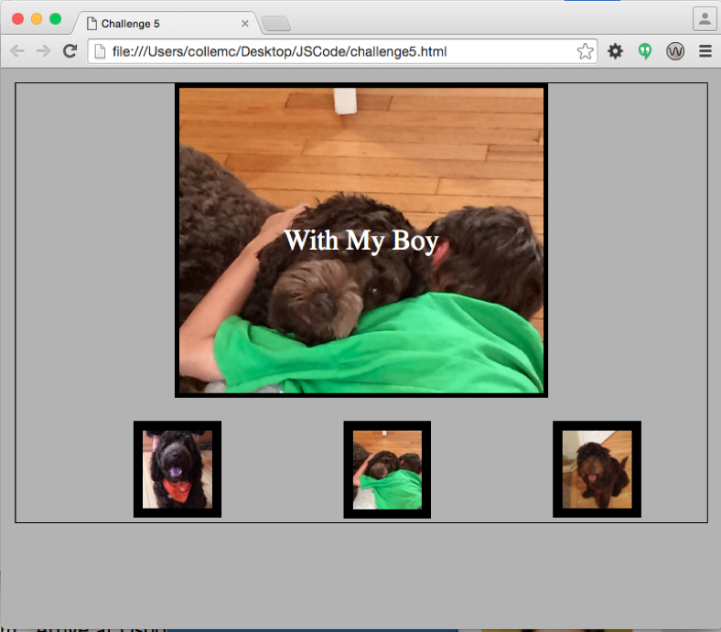 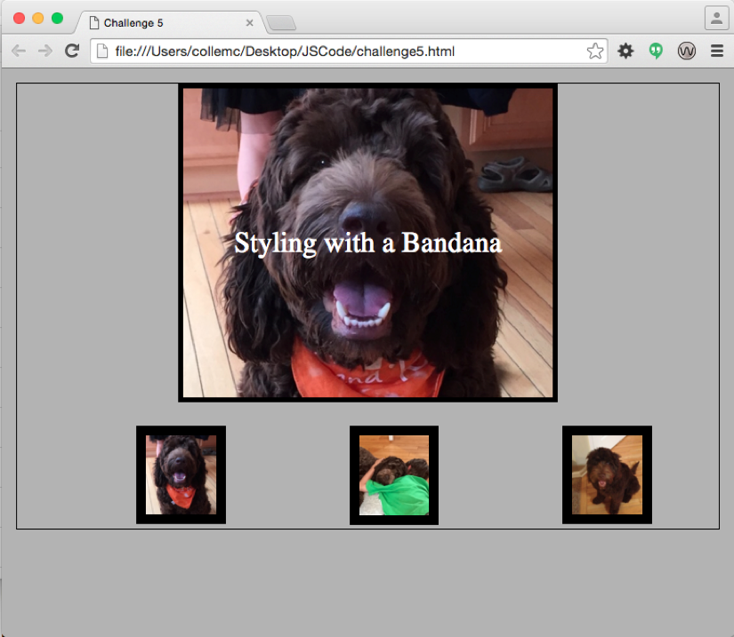

**Mouse over 2nd picture Mouse over 1st picture**

**Mouse is hovered each thumbnail**

***The KEY component to this challenge is that you may not hardcode any values***. At anytime I can change the value of the src and/or alt attribute of an image and the code should still work. I should be able to add/delete images and it should still work. ***You must use JavaScript for this assignment, not jQuery.*** You may not use code taken from the internet for Challenge 5.